**MODERN EDUCATION SOCIETY’S**

**NOWROSJEE WADIA COLLEGE**

**19, LATE PRIN.V.K JOAG PETH,**

**PUNE 411001**



**Project Report**

**On**

**“ADVERTISEMENT PROVIDER DATA AGGREGATOR(OPEN ADS NETWORK)”**

**PROJECT BY**

**DNYANESHWAR DERLE (10136)**

**SAWANKUMAR LONDHE (10151)**

**HUMAYUN INAMDAR (10120)**

**UNDER THE GUIDANCE OF**

**PROF.PRACHI PATEKAR**

**MODERN EDUCATION SOCIETY’S**

**NOWROSJEE WADIA COLLEGE**

**19, LATE PRIN.V.K JOAG PETH,**

**PUNE 411001**



**CERTIFICATE**

This is to certify that **DNYANESHWAR DERLE,SAWANKUMAR LONDE,HUMAYUN INAMDAR** of M.Sc. (Computer Science) has successfully completed Project titled **“ADVERTISEMENT PROVIDER DATA AGGREGATOR ”** for M.Sc. (Computer Science) SEM II for the academic year 2017-2018.

Project Guide Head of Department

(Computer Science)

External Examiner: \_\_\_\_\_\_\_\_\_\_\_\_\_\_\_\_\_\_\_\_\_\_ Internal Examiner: \_\_\_\_\_\_\_\_\_\_\_\_\_\_\_\_\_\_\_\_\_\_\_\_

Date: \_\_\_\_\_\_\_\_\_\_\_\_\_\_\_\_\_\_\_\_

**Acknowledgement**

“***No major process of creation involves an individual”*** and the creation of this project is by no means an exception for the above statement.

We students of M.Sc. (computer science) part-1 feel a great source of gratitude and pleasure in presenting this report of “ADVERTISEMENT PROVIDER DATA AGGREGATOR ” web application.

Many people have helped us in creating this project. We would like to express my gratitude and thanks to those helping hands.

We would like to thank **Prof.Prachi Patekar** our Project Guide, for guiding us through my entire project.

We would also like to thank **Dr. Mr.C.S.Nimkar** (H.O.D. Computer Science) and all the staff of Computer Science Department for the continuous support and encouragement.

It would have been a Herculean task to develop this project without the support of the all the people mentioned above.

**CONTENTS:**

|  |  |  |
| --- | --- | --- |
| **SR NO** | **TITLE** | **PG. NO** |
| 1 | Problem definition/Introduction | 5 |
| 2 | Scope of the work | 5 |
| 3 | Feasibility study | 6 |
| 5 | ER diagram | 8 |
| 6 | Use case diagram. | 9 |
| 7 | Class diagram | 10 |
| 8 | Sequence diagram | 11 |
| 9 | Data Dictionary | 12 |
| 10 | I/O screens | 15 |
| 11 | Test cases | 22 |
| 12 | Conclusion | 25 |
| 13 | Bibliography & References | 26 |

**Problem Definition and Need for the new system**

* The object of all business is to make a profit and increase the sales product. This only possible if the product is wieldy polished to the user and the final consumers. Advertisement denotes a specific attempt to popularize a specific product or service at certain cost, that is method of publicity.
* Why project “**Ad Provider Data Aggregator**” Advertisement is some way publicity of customer product. The owner of the product will be in profit if an only if advertising is in proper manner and keeping track of advertising there product.
* Here in our project, we are giving graphical representation and analysis of their records.
* From graphical representation, they can see whether our business is in loss or in profit.

**Scope of the work**

* By using system, customers can display their **Advertises** in specific Blogger.
* System will keep track of all the **respected websites** where Ads have been flashed.
* Also it maintains the **count** collected by every website for the particular Ad through CTR (**click-through rate**).
* System will provide this service for **specific period of time**.
* Required **reports** will be generated.
* The system will help the customer, to keep track of the responses by viewing the **detail analysis**, of the progress of the Advertisement.

**Feasibility study**

Feasibility study for the project is mainly divided as

1. **Technical feasibility:** This includes understanding of present technical resources and their applicability to the development of proposed system

Hardware and Software requirements

1. **Hardware Requirements**

1. Well equipped PC (with monitor, mouse, Keyboard etc.)

2. Processor Pentium 3 and above

3. Ram 512 MB

4. Hard Disk 1 GB (min)

**2) Software Requirements**

For development: Windows 7 and above/ Xp, Net beans 7.0.1, JDK and JRE (1.8),

Front end : Java Runtime Environment JSP (java), HTML, Javascript.

Back end: MySQL Server

As all the software used is easily available the proposed system is technically feasible

**2) Economic Feasibility:**

Based on the estimates that have been gathered from the preceding sections of the study, the organization needs to determine its overall financial situation. Sources and uses of financing should be listed. The system does not require any hardware or software to be additionally purchased. Since the interface for this system is developed using existing resources and technologies. The total cost incurred for development and the implementation will be less .Therefore, our system is economically feasible.

As all the software required are Freely available the cost required to develop the project is affordable and hence the project is economically feasible.

**3) Operational feasibility :**

The developed project is a web application. The basic knowledge of computer is enough for the user to use the application. Application runs only in the browser as a web page and doesn’t affect the execution of other programs, No special permission/ setups installation is required. No special training to the user is required hence the proposed system is operationally feasible.

**ANALYSIS LEVEL DIAGRAM:**

**ER-DIAGRAM:**

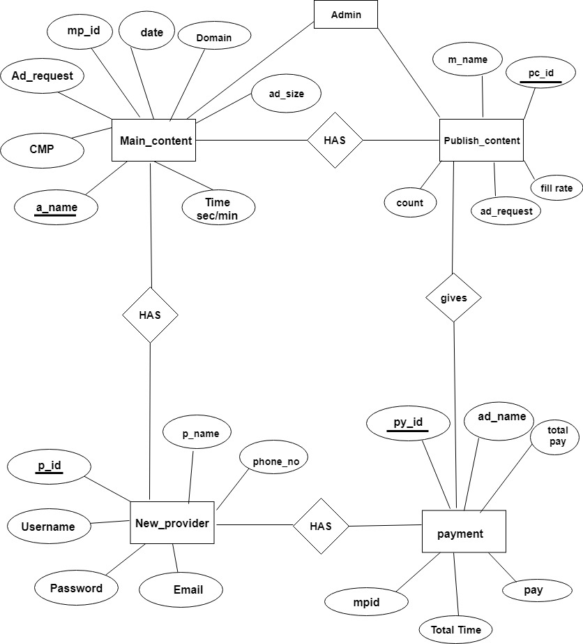

**CLASS DIAGRAM:**

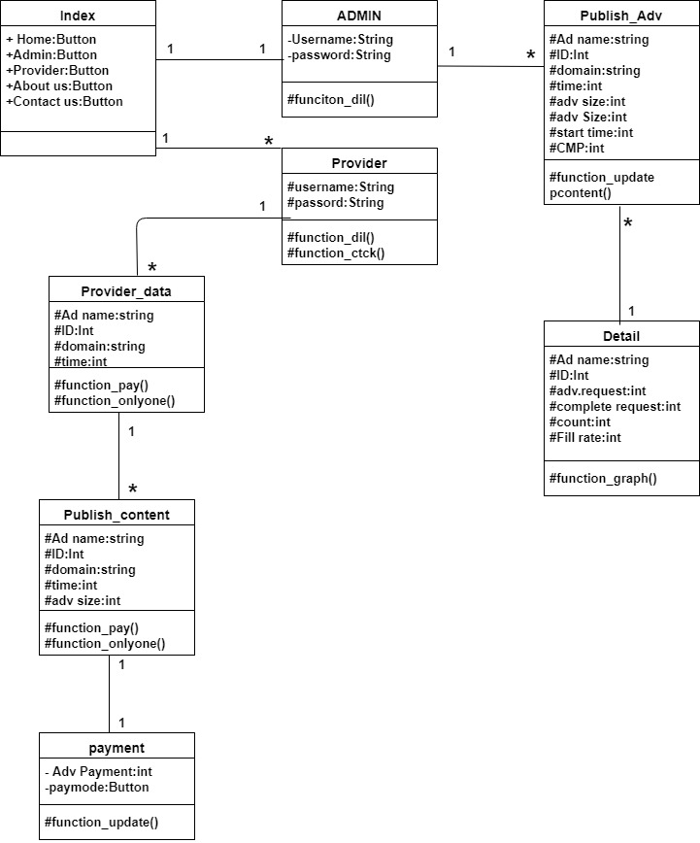

**USE CASE DIAGRAM:**

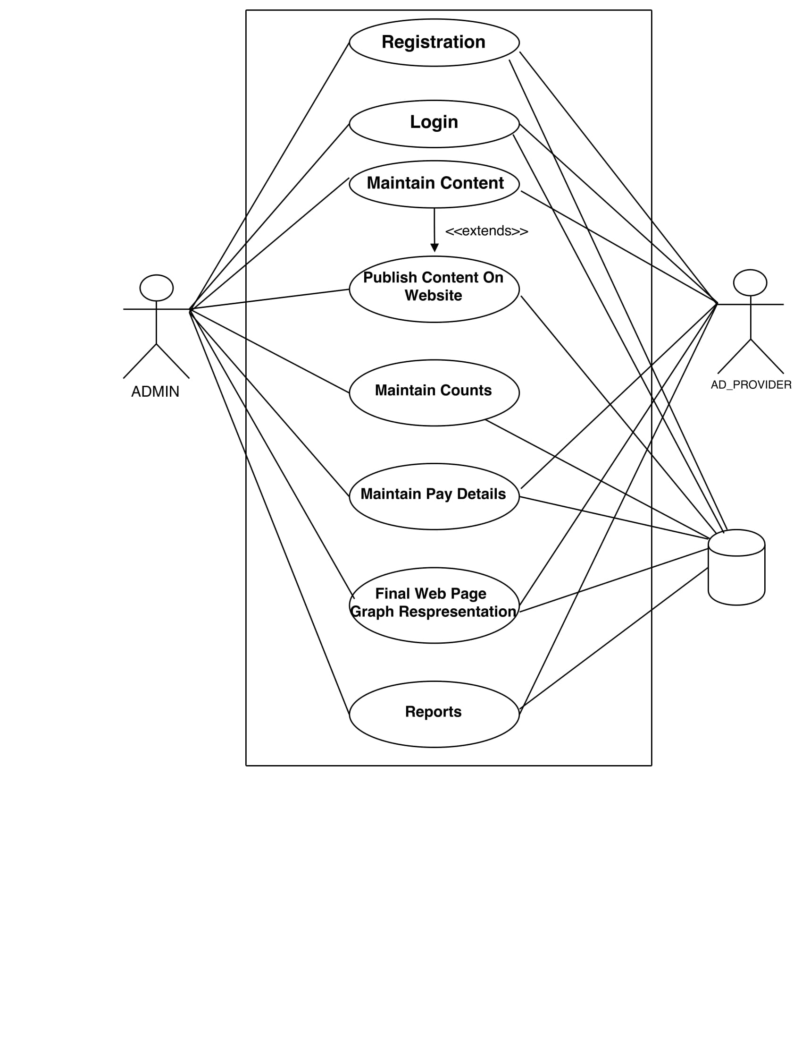

# DESIGN LEVEL DIAGRAM

# SEQUENCE DIAGRAM:

# C:\Users\Sawankumar\Downloads\adseq.jpg

# DATA DICTIONARY:

# Admin:

|  |  |  |  |  |  |
| --- | --- | --- | --- | --- | --- |
| Field | Data type | Key | Null | Default | Extra |
| User | varchar(45) | Primary key | NO | NULL | - |
| Pass | varchar(15) | - | NO | NULL | - |

# new\_Provider:

|  |  |  |  |  |  |
| --- | --- | --- | --- | --- | --- |
| Field | Data type | Key | Null | Default | Extra |
| pid | int(11) | Primary key | NO | Null | - |
| P\_name | varchar(50) | - | NO | Null | - |
| Ph\_no | int(11) | - | NO | Null | - |
| Email | varchar(45) | - | NO | Null | - |
| User | varchar(45) | - | NO | Null | - |
| Pass | varchar(45) | - | NO | Null | - |
| r\_pass | varchar(45) | - | NO | Null | - |
| passwd | varchar(30) | - | True | None | - |

# m\_content:

|  |  |  |  |  |  |
| --- | --- | --- | --- | --- | --- |
| Field | Data type | Key | Null | Default | Extra |
| a\_name | varchar(45) | Primary key | NO | Null | - |
| mid | varchar(45) | - | NO | Null | auto\_increment |
| date | Date | - | NO | Null | - |
| domain | varchar(45) | - | NO | Null | - |
| a\_file | varchar(45) | - | NO | Null | - |
| a\_size | varchar(45) | - | NO | Null | - |
| s\_time | time | - | NO | Null | - |
| time\_sec1 | int(11) | - | NO | Null | - |
| s\_time2 | time | - | NO | Null |  |
| time\_sec2 | int(11) | - | NO | Null |  |
| s\_time3 | time | - | NO | Null |  |
| time\_sec3 | int(11) | - | NO | Null |  |
| cmp | int(11) | - | NO | Null |  |
| status | varchar(45) | - | YES | Null |  |
| pid | int(11) | NULL | NO | Null |  |
| Status1 | varchar(45) | - | YES | Null |  |

# p\_content:

|  |  |  |  |  |  |
| --- | --- | --- | --- | --- | --- |
| Field | Data type | Key | Null | Default | Extra |
| pc\_id | int (11) | Primary key | NO | Null | auto\_increment |
| Ad\_request | double | - | YES | Null | - |
| Billable\_impression | double | - | YES | Null | - |
| count | int(11) | - | YES | Null | - |
| fill\_rate | double | - | YES | Null | - |
| m\_name | varchar(20) | MUL | YES | Null | - |

# payment

|  |  |  |  |  |  |
| --- | --- | --- | --- | --- | --- |
| Field | Data type | Key | Null | Default | Extra |
| py\_id | int(11) | Primary key | NO | Null | auto\_increment |
| Ads\_name | varchar(45) | - | YES | Null | - |
| Total\_time | int(11) | - | YES | Null | - |
| Pay | int(11) | - | YES | Null | - |
| Total\_pay | int(11) | - | YES | Null | - |
| Pay\_mod | varchar(45) | - | YES | Null | - |
| Pay\_date | Date | - | YES | Null | - |
| mpid | int(11) | MUL | NO | Null | - |

# Screen Shots:

# Home screen:

# F:\ScreenShots\home.png

# Provider Login or Register:

# 

# Provider Data:

# 

# Publish content of provider:

# F:\ScreenShots\Publish_content.png

# Provider Modify Data:

# F:\ScreenShots\Provider_modify_details.png

# Provider Adv Reports:

# 

# Provider Count Graph:

# Provider Payment:

# 

# Provider Bill:

# 

# Admin Login:

# F:\ScreenShots\Admin.png

# Customer data:

# F:\ScreenShots\Admin_custom_data.png

# Provider Request Reports and More details:

# 

# Provider Adv Reports:

# 

# Testing

* All fields on page (e.g. text box, button) are aligned properly.
* Font size, style and colour for headline, description text, labels, infield data, and grid info are of standard form
* Upon click of any input text field, mouse arrow pointer gets changed to cursor..

## Test Cases:

### GUI Testing:

|  |  |  |  |
| --- | --- | --- | --- |
| Test Case ID | Test Case Scenario | Expected Result | Actual Result |
| 1 | Home Button | >Should display main GUI window project. | Successful |
| 2 | Admin button | >Admin login/password.  >Admin should get all the records for provider.  >Admin should able to see reports. | Successful |
| 3 | Provider button | >Provider Login/password.  >Provider should get Advertisement form. | Successful |
| 4 | Contact button | >Should able to give info regarding contacts. | Successful |
| 5 | About button | It should give all information and guideline for project | successful |

## Functionality testing

## Provider cases:

|  |  |  |  |
| --- | --- | --- | --- |
| Test Case ID | Test Case Scenario | Expected Result | Actual Result |
| 1 | Provider Ad Form | i) It should only accept characters and added to database.  ii) Special symbols should not be accepted.  iii)All Fields are mandatory | Successful |
| 2 | Provider Payment | i)Generating the payment as per payment mode selected by provider | Successful |
| 3 | Provider Bill | i) Generating the bill as per Advertisements detail. | Successful |
| 4 | Provider Reports | i). Generating the reports/Graphical representation as per Advertisements detail.  ii)Print option for report should work properly | Successful |

## Admin cases:

|  |  |  |  |
| --- | --- | --- | --- |
| Test Case ID | Test Case Scenario | Expected Result | Actual Result |
| 1 | Admin | Admin should able to see the all provider info. | Successful |
| 2 | Admin Publish Button | i) Admin able to publish the advertisements of provider by clicking on publish button | Successful |
| 3 | Admin Maintain content | 1. Admin should able to maintain the data of Adv. Provider. 2. Admin should able to keep the track of count, complete request, Fill Rate. | Successful |
| 4 | Admin Reports | i). Generating the reports/Graphical representation as per Advertisements detail.  ii)Print option for report should work properly | Successful |

**Conclusion:**

Hence we can conclude that the provider can easily publish there Advertise on this project .Our system produces reports and graphical reports of given Adervrtise by provider.

The admin can manage all details of Provider easily.

* **User Friendly** :

The System has got much Simplified screen which makes the system fast enhances quick and accurate data.

* **Easy to Learn :**

The System is easy to understand, this is mainly due to simple functionality. Even a Layman can be trained to use this system.

* Working on this project was a good experience. We understood the Importance of planning and designing phase of the Software Development.
* Developing the project has helped us to gain some experience on real time development procedure.
* Manual paper work which required lots of time and which is lengthy work is removed successfully using this application

**Bibliography and References**

**Book Referred:**

**1**. Complete Reference SQL.

By-Groff Weinberg

**Reference Websites:**

http://www.javaworld.com

[http://javarevisited.blogspot.in](http://javarevisited.blogspot.in/)

[http://google.com](http://google.com/)

[http://stackoverflow.com](http://stackoverflow.com/)

http://w3school.com